### These charts are based on CAISO and SERVM simulated pricing posted to the DER page [HERE](https://www.cpuc.ca.gov/industries-and-topics/electrical-energy/demand-side-management/energy-efficiency/der-cost-effectiveness)

These charts show comparisons for both 2021 and 2022 CAISO versus SERVM simulated pricing.

### 2021 Energy Price Comparison

Staff calibrated energy prices between CAISO’s actual 2021 market results and our simulated 2021 SERVM market results. Below are charts that compare price results. We compared the SERVM real time final market price compared to the energy component of the CAISO prices. This effect is also pronounced in December 2022.

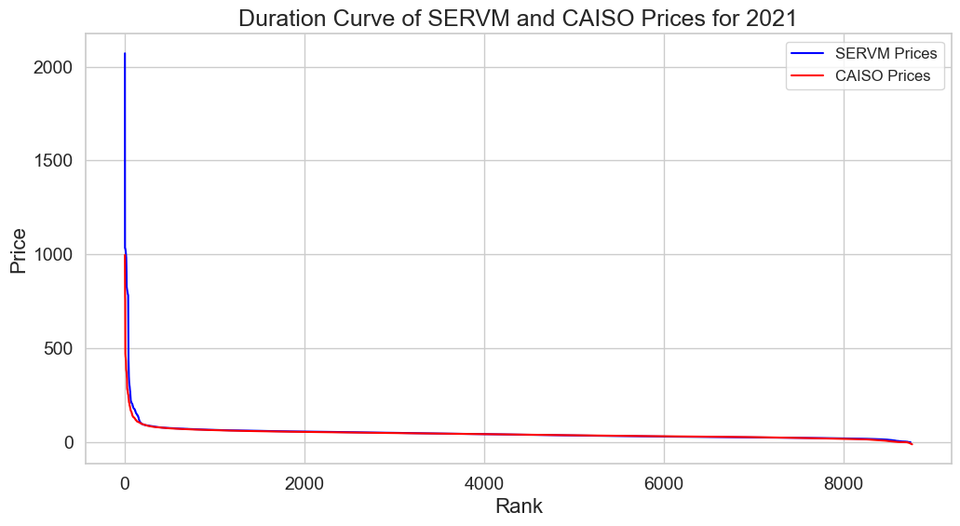

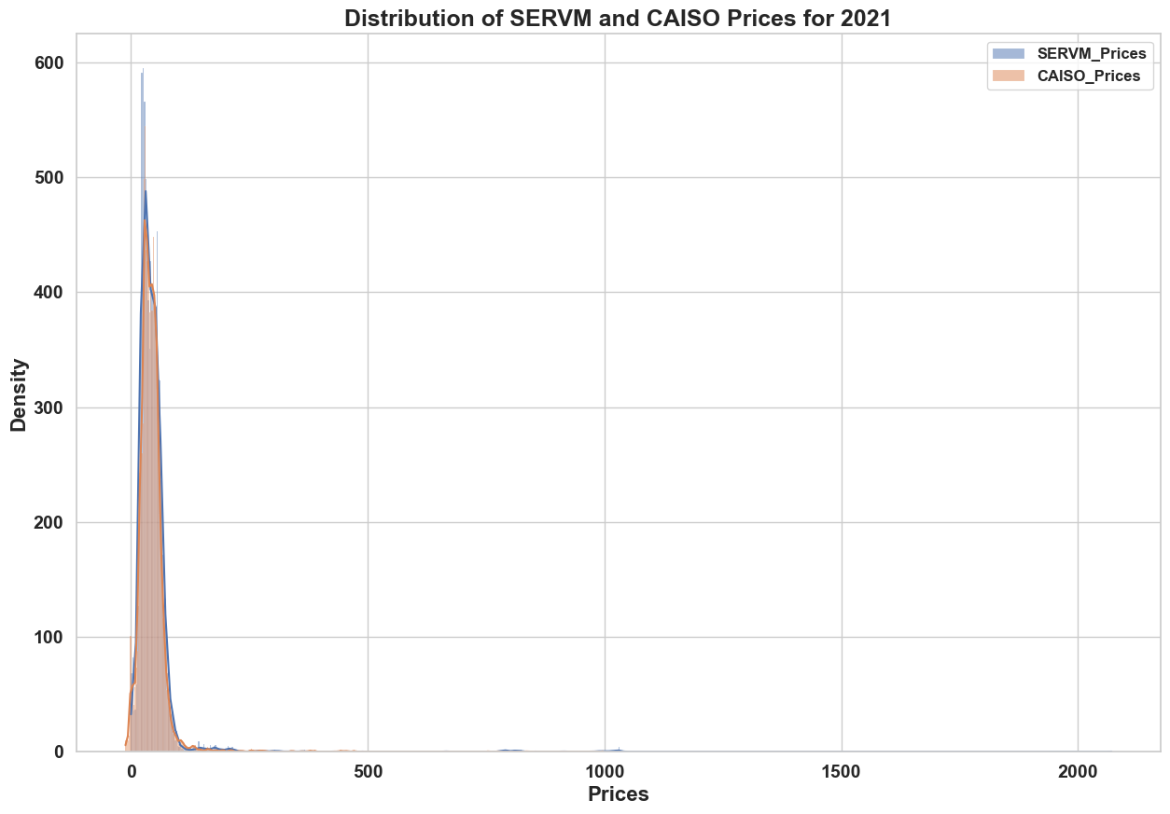

These charts compare prices and heat rates. A key finding is that high gas prices lead to high electricity prices, and we can see that both CAISO and SERVM are affected by gas prices by seeing that the IMHR chart appears to show better alignment. This can clearly be seen in the month of February.

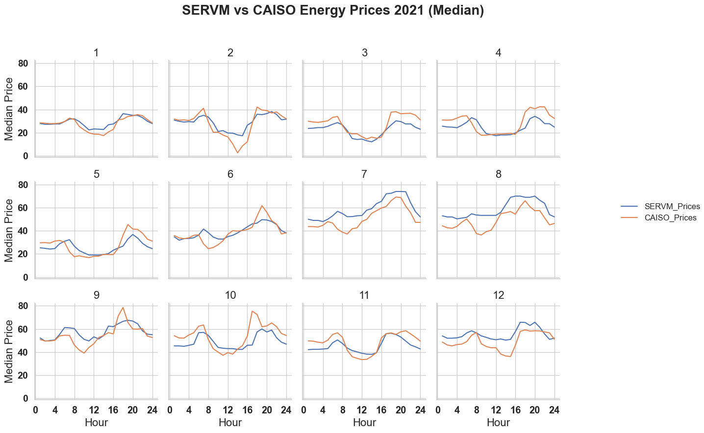

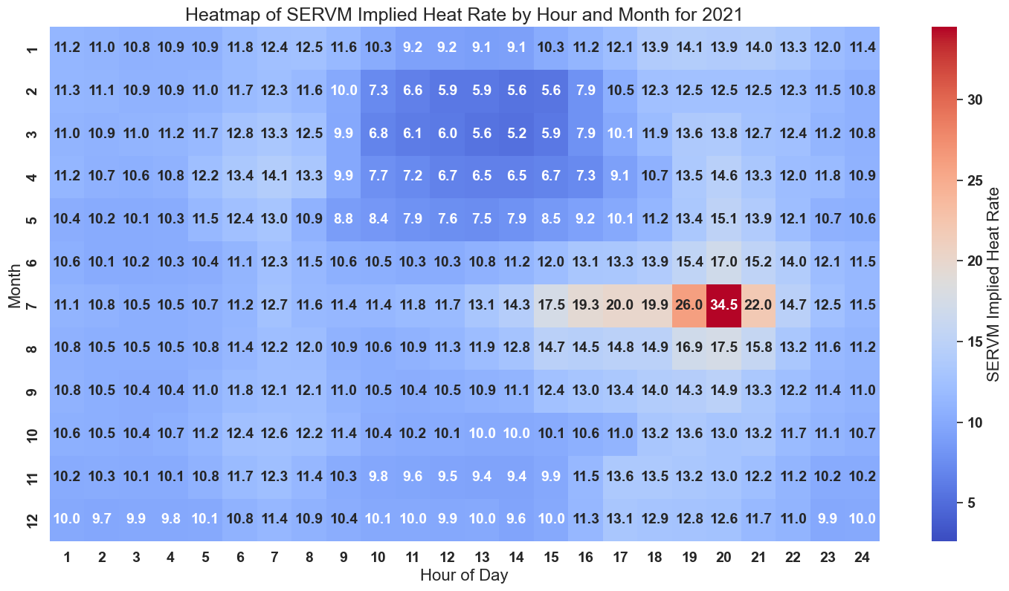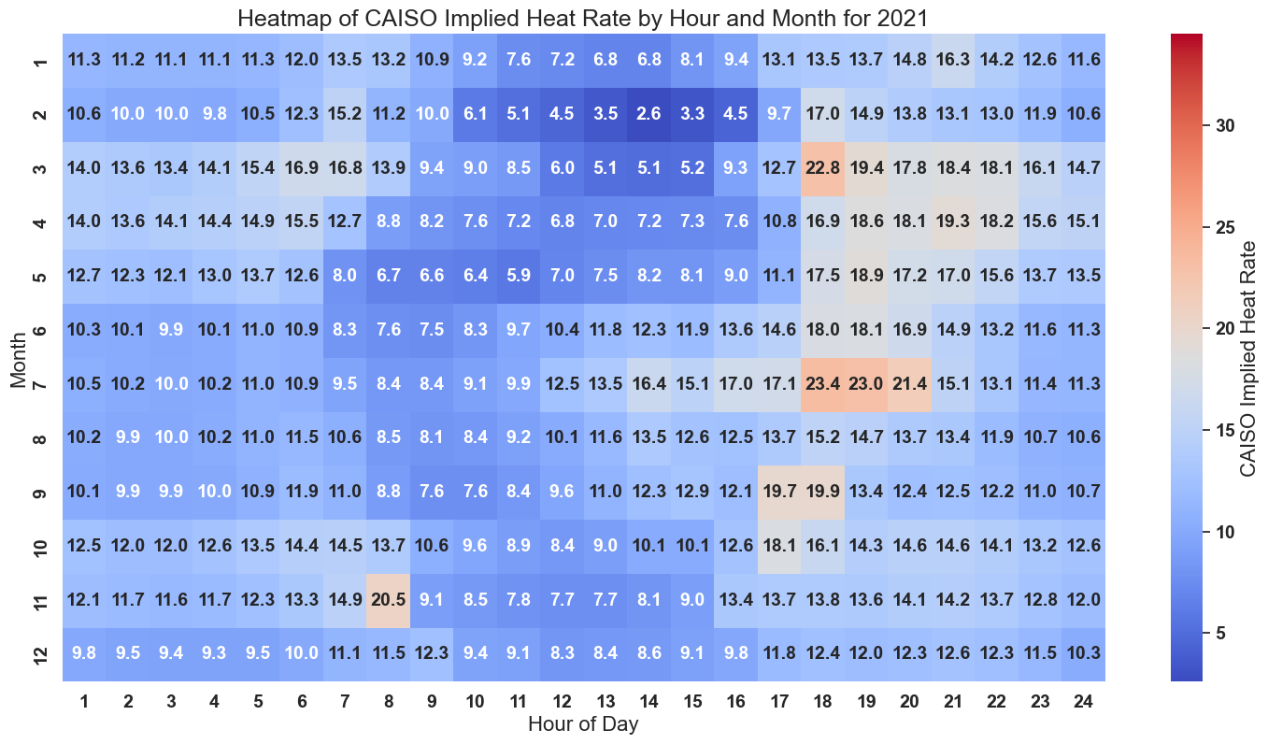

## 2022 Energy Price comparisons

CPUC calibration of energy prices showed better results for 2022, given the ORDC was aligned to 2022 CAISO prices rather than 2021 prices. This 2022 calibrated ORDC will be used for the actual ACC forecasting runs.

Figure below compares the MAE (Mean Absolute Error) and MSE (Mean Squared Error) calculated from our benchmarking results for 2022 CAISO historical year. These metrics assess the disparities between actual and forecasted prices.

