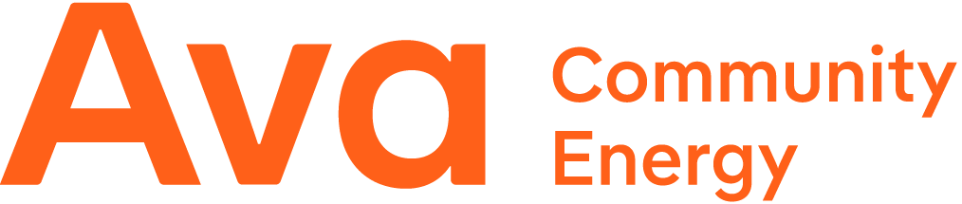

2025 Supplier Diversity Annual Report & 2026 Annual Plan
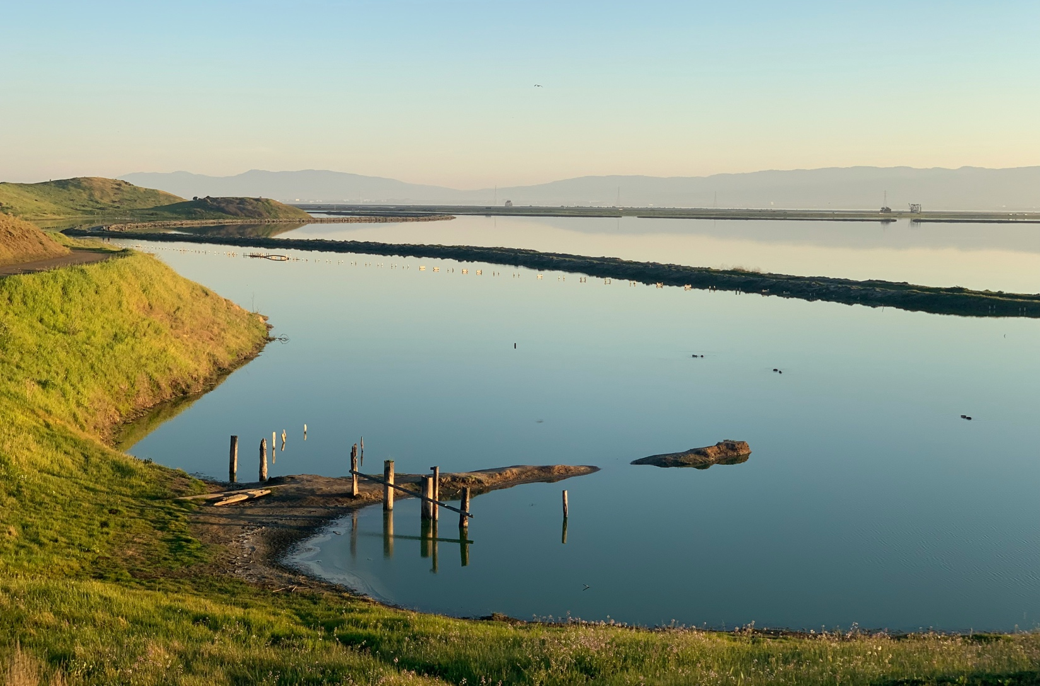

Ava Community Energy  March 2, 2026 | 

Table of Contents
Message from Ava CEO Howard Chang 3
Executive Summary 4
2025 Annual Report 6
9.1.1 Description of Supplier Diversity Program Activities During the Previous Calendar Year 6
9.1.2 Supplier Diversity Results of Goods and Services (Non-Power Purchases) 11
9.1.2 Description of Diverse Suppliers with Majority Workforce in California 15
9.1.3 Supplier Diversity Program Expense 16
9.1.4 [Title Intentionally Omitted] 16
9.1.5 Description of Prime Contractor Utilization of Diverse Subcontractors 16
9.1.6 List of Supplier Diversity Complaints Received and Current Status 17
9.1.7 Description of Efforts to Recruit Diverse Suppliers in Low Utilization Categories 17
9.1.8 [Title Intentionally Omitted] 17
9.1.9 Description of Supplier Diversity Activities and Progress in Power (Energy) Procurement 17
9.1.9: Supplier Diversity Results in Power (Energy) Procurement 19
2026 Annual Plan 20
9.1.10 [Title Intentionally Omitted] 20
9.1.11 [Title Intentionally Omitted] 20
10.1.1 [Title Intentionally Omitted] 20
10.1.2 [Title Intentionally Omitted] 20
10.1.3 [Title Intentionally Omitted] 20
10.1.4 [Title Intentionally Omitted] 20
10.1.5 [Title Intentionally Omitted] 21
10.1.6 [Title Intentionally Omitted] 21
10.2 Description of Supplier Diversity Program Activities Planned for the Next Calendar Year 21
10.2 Plans to Encourage Prime Contractors to Subcontract Small, Local, and Diverse Businesses 22

Message from Ava CEO Howard Chang
As we look back on 2025, I am proud of how Ava has stayed true to our mission of driving increasing access to clean energy while serving the needs of our customers and the well-being of our community. This year underscored our strong financial stewardship and unwavering commitment to innovation.  We started the year by returning $22 million in bill credits to customers, with higher credits going to income-qualified households. In April, we expanded our service to the cities of Stockton and Lathrop, marking one of the largest growth milestones in Ava’s history. More than 120,000 new households and businesses now have access to cleaner electricity at lower rates.  Beyond electricity service, we continued to launch innovative programs to help customers participate in the clean energy transition. Ava SmartHome Charging, launched in March, rewards EV drivers for optimizing their home charging to use more renewable energy and reduce peak demand. We also debuted one of the nation’s largest  e-bike incentive programs, Ava Bike Electric, offering thousands of rebates of up to $1,500. The $10 million budgeted for this program to increase access to affordable, electric transportation also serves as a community reinvestment at our 28 local participating bike shops. |  |  |   To support our continued growth and innovation, we welcomed Russell “Rusty” Mills as Senior Vice President, Chief Financial Officer, and Treasurer. Rusty brings over 25 years of experience in energy and public finance to our team.  Our commitment to community partnerships also remained strong. This year, we sponsored 36 local organizations and attended over 70 community events across our service area, reinforcing our ties with the communities we proudly serve.  Through customer savings, new programs, and long-term investments in clean energy, every step we took in 2025 was anchored in what matters: affordability, reliability, and a cleaner future. Together, we are making that future a reality.    Howard Chang  CEO, Ava Community Energy

Executive Summary
Ava Community Energy (“Ava”) hereby submits its fifth Supplier Diversity Annual Report in accordance with the requirements of SB 255 (2019, Bradford).

Ava is a Joint Powers Authority (“JPA”) formed on December 1, 2016, pursuant to California Government Code §§ 6500 et seq. to provide community choice energy to its original member jurisdictions: the County of Alameda and each of the following cities incorporated therein: Albany, Berkeley, Dublin, Emeryville, Fremont, Hayward, Livermore, Oakland, Piedmont, San Leandro, and Union City. Ava started serving Alameda County businesses and municipalities in June 2018 and began serving residential customers in November 2018. In 2020, Ava added the Alameda County cities of Newark and Pleasanton, as well as the city of Tracy in San Joaquin County, to the JPA, and began serving customers in those new jurisdictions in April 2021. In 2022 and 2023, respectively, Stockton and Lathrop were accepted as Ava’s newest jurisdictions, with service beginning in April 2025. In 2024, Ava expanded its service territory with the addition of San Joaquin County, with service scheduled to begin in 2026.

As a California local government entity bound by California Proposition 209, Ava is prohibited from considering race, sex, color, ethnicity, or national origin in its contracting. Accordingly, in contrast to California’s electrical corporations, Ava does not set supplier diversity targets or goals. Ava has, however, developed programming for outreach and education around General Order 156 (“GO 156”) to ensure that Ava’s current suppliers and potential future suppliers are aware of the California Public Utilities Commission (“CPUC”) supervised Supplier Clearinghouse and the opportunities that may come along with certification. Ava also offers technical assistance to suppliers who are interested in applying to the Supplier Clearinghouse for certification as a Women-, Minority-, Service-Disabled Veteran-, LGBT-, and/or Persons with Disabilities Business Enterprises (diverse businesses).

Ava’s contracting process is not influenced by the Supplier Clearinghouse certification status of its potential suppliers. Ava does not collect data from its suppliers on their status as a diverse business or certified vendor until after the contract with Ava is executed. To provide the state with data on Ava’s annual spend with diverse suppliers, Ava requests its suppliers to provide information on their diverse status after contract execution through a Supplier Diversity Questionnaire.

Educating suppliers about the Supplier Clearinghouse and providing technical support is expected to increase certification levels of diverse firms over time. Certification enhances vendors’ visibility with non-government utility companies that utilize the Clearinghouse database in their search for suppliers. Furthermore, if certified vendors gain additional contracts with the utility companies, they broaden their value as potential suppliers to entities such as Ava based on their additional experience and expertise. In other words, encouraging greater participation in the Supplier Clearinghouse can strengthen and broaden the pool of experienced diverse suppliers available in the marketplace in the future.

In accordance with California law, Ava does not exhibit preference for Women Business Enterprises (“WBE”), Minority Business Enterprises (“MBE”), or LGBT Business Enterprises (“LGBTBE”) in its solicitations or procurement selections. However, Ava does employ four procurement preferences, incorporated into Ava’s Administrative Procurement Policy. In 2021 Ava maintains a preference for Disabled Veteran Business Enterprises (“DVBE”), as well as a preference for businesses located in a Disadvantaged Community (“DAC”) as identified by the California Environmental Protection Agency’s (“CalEPA”) CalEnviroScreen Tool. Ava also maintains a preference for union labor and local suppliers located in Ava’s service territory.

2025 Annual Report

9.1.1 Description of Supplier Diversity Program Activities During the Previous Calendar Year
Ava recognizes its responsibility and opportunity as a local public agency that invests millions of dollars into the community and state every year. As such, Ava is strongly committed to investing directly in its service territory to the greatest degree possible. This takes the form of maximizing direct purchasing from companies and organizations within Alameda County, including unincorporated Alameda county, as well as its service territory within San Joaquin County. It also takes the form of deploying clean energy assets and customer programs that create local jobs and provide economic benefit and community resilience to customers.

In 2025, Ava had a Net Procurement of $21,448,306.14 spent on professional services, administrative expenses, and community grants and sponsorships. As recognized in CPUC Decision (D.) 22-04-035, Ava, like all Community Choice Aggregators (CCAs), faces different total purchasing needs, along with legal restrictions on supplier selection criteria relative to the investor-owned utilities. To the extent that an electric service provider is also a public agency, the Commission acknowledges that additional legal restrictions on data collection may apply. Accordingly, Ava’s Net Procurement amount is limited in size and scope compared to the Net Procurements of the investor-owned utilities. Diverse supplier spend is only a small portion of annual Net Procurement, as is further detailed in Sections 9.1.2 and Section 9.1.9. To promote and grow the statewide Supplier Diversity program, Ava continues to approach and grow Supplier Diversity activities in an innovative way that drives the program forward, while staying within the legal bounds that constrain CCAs from setting targets and expressing preference for diverse suppliers. Below are the activities undertaken in 2025 to that end.

Internal Activities
- Board of Directors & Staff Engagement
  - In 2025, Ava’s Board comprised 11 members from underrepresented minority groups and 10 women, reflecting strong diversity across its 19-member body.
  - Ava staff participated in an internal training related to GO 156 and the Supplier Diversity program, including requirements, resources, and implications it has for Ava’s solicitations.
- CCA Collaboration
  - Ava staff participated in all 4 multi-CCA meetings to share program actions, updates and discuss potential collaborations.
- CPUC Collaboration
  - In May 2025, the CPUC staff opted not to hold the annual report debrief and instead requested program-related information via email, which Ava provided.
  - Ava staff participated in a quarterly call series with CPUC staff and representatives from other CCAs to discuss challenges and opportunities related to GO 156 and SB 255.
- 2026 Planning
  - During the sixth year of Ava’s Supplier Diversity program, staff continued to refine existing initiatives and develop new components to further increase vendor awareness of the CPUC’s Supplier Clearinghouse program. For instance, Ava is encouraging eligible suppliers to pursue certification with the Supplier Clearinghouse.
  - Ava staff has also continued to improve internal processes and data collection methods to make reporting even more thorough and robust. Earlier in the year, Ava’s legal team launched a digital contract management platform to gain better insights into subcontracting and diverse suppliers.

External Activities
- Chamber Memberships
  - Ava continued its membership in the chambers of commerce for all JPA member cities. Ava also continued membership with ethnic chambers of commerce including Oakland African American Chamber of Commerce, Oakland Chinatown Chamber of Commerce, and Oakland Latino Chamber of Commerce.
  - Ava staff sent out resources such as information regarding customer services and rebate programs, details of local sponsorship opportunities, rate information, and other agency news, to the Oakland African American Chamber of Commerce, Oakland Latino Chamber of Commerce, and Oakland Chinatown Chamber of Commerce.
- Solicitations
  - Ava uses standard language pertaining to supplier diversity in all goods, services, and power solicitations. Ava provides background on GO 156, on Ava’s legal inability to exhibit preference to diverse suppliers, and supports certification of eligible contractors.
  - Ava has also developed standard slides on GO 156 and certification resources to be used in all solicitation webinars.
  - Ava maintains an evaluation matrix to standardize point preferences for consistency with its Board-approved Workforce and Environmental Justice Project Selection Criteria. This document, developed with local union representation, defines project selection criteria and describes the standards for entering into long-term offtake agreements for resources developed using union workforce and prioritizing environmental justice. Ava provides annual training and regular reminders to staff to ensure this scoring matrix is used consistently.
- Local Purchasing
  - Ava purchases goods and services from small and local businesses to the greatest extent possible. Ava’s Administrative Procurement Policy provides that designated procurements of goods, non-professional services, and professional services may be made without a formal solicitation; these types of procurements are more likely to be sourced from small and/or local businesses, for which Ava predominantly uses the Alameda County Small, Local, and Emerging Business (“SLEB”) Directory to source potential vendors. For larger procurements, and particularly those for which a formal competitive solicitation is issued, potential suppliers may receive points for their small or local business status, but Ava does not make decisions solely based off these classifications.
- Labor & Workforce Development
  - Ava expresses a strong preference (as detailed and codified in the Administrative Procurement Policy or in the Workforce and Environmental Justice Project Selection Criteria), and in most cases a contractual requirement, for the use of local and union labor requirements. As such, Ava is more likely to contract with small and diverse businesses.
  - Ava also has growing partnerships to support local workforce development opportunities for community members. Some of this work is in direct relation to the deployment of Ava’s local clean energy programs, and some is more generally dedicated to advancing clean energy jobs training, workforce development, and career pathways for young people.
  - As mentioned in Board of Directors engagement, Ava has worked to incorporate evaluation criteria regarding the hiring of local and equitable workforces, in the spirit of workforce development. The criteria were approved by the Board of Directors in January 2024.
- Community Sponsorships
  - Ava is dedicated to reinvesting in its communities through a series of ongoing financial sponsorships and grants to local community-based organizations and programs. Community Sponsorships are awarded three times per year. The maximum award amount is $2,500 per organization per award round. Community Sponsorships go to all sorts of incredible local organizations in categories spanning from STEM education to arts & music to addressing food insecurity. In 2025, 56 unique organizations received Community Sponsorship.
  - Ava continued to be an official Climate Justice partner of the Oakland Roots Sports Club (“Oakland Roots”), a professional soccer club on a mission to be a model community partner. In 2025, the team was sponsored at $141,000 across 17 home games, supporting the Oakland Roots as a mission-driven soccer club that celebrates community, environment, and purpose, while they continue building a diverse and inclusive community of fans from across Northern California. In turn, Ava hosts activations at home games to engage fans of all ages in learning more about the agency.
  - Ava also renewed sponsorship of the Oakland Soul team, in the women’s division, for $34,000 across 6 home games, for a third year.
  - Additional sponsorships included soccer teams Pleasanton Rage and Stockton Cargo both for $5,000 for 6 home games, and baseball teams Stockton Ports for 66 games at $40,000, and Oakland Ballers for 48 games at $25,000.
- 2025 Community Investment Grants
  - Ava awarded grants in this funding cycle (2023-2027) with the objective of investing in the community while educating and empowering Ava customers for the energy transition. As of December 2025, five Requests for Proposals (RFPs) were posted:
    - Induction Education and Awareness - 1 (2-year) grant awarded to Channing St. Copper (grant terminated early, after 12 months.)
    - Clean Energy Jobs Training for Youth - 2 (3-year) grants awarded 1) Rising Sun, 2) AGAPE (partnership between Cypress Mandela Training Center and Revalue.io)
    - Youth Clean Energy Education (K-12) - no grant was awarded
    - Community Organizing and Capacity Building for Resilience Hubs: 1 (18 month) grant awarded to Emerald Cities Collaborative
    - Community-owned EV Chargers - 2 (3-year) grants awarded (GTC, IPL)
- 6 grantees were selected:
  - Channing St. Copper – Induction Cooking Education and Awareness
    - (Approved $ Award: $300k / Total Awarded: $150k, grant terminated early)
  - AGAPE (partnership between Cypress Mandela Training Center and Revalue.io) – Clean Energy Jobs Training for Youth (Ages 15-24),
    - (Approved $ Award: $300k / Total Awarded YTD: $100k)
  - Rising Sun – Clean Energy Jobs Training for Youth (Ages 15-24),
    - (Approved $ Award: $300k / Total Awarded YTD: $100k)
  - Interfaith Power and Light – Community EV Charging Grant,
    - (Approved $ Award: $300k / Total Awarded YTD: $100k)
  - Green the Church – Community EV Charging Grant,
    - (Approved $ Award: $300k / Total Awarded YTD: $100k)
  - Emerald Cities Collaborative – Community Organizing and Capacity Building for Resilience Hubs.
    - (Approved $ Award: $300k / Total Awarded YTD: $100k)
- In December 2023, Ava awarded $150,000 to Channing St. Copper to support Induction Cooking Education and Awareness (with an additional $150,000 to be disbursed over the following year for a total of $300,000 over two years). This grant funds electrification education and awareness at community events, with targeted outreach to residents in Equity Priority Communities.
- The Clean Energy Jobs Training for Youth (Ages 15-24) RFP resulted in two grant awards of up to $300,000 each.
- AGAPE and Rising Sun were selected to serve different regions within Ava’s service area.
- Supplier Diversity Questionnaire
  - Ava sent requests to prospective respondents from the Ava Supplier Diversity email address – supplier-diversity@avaenergy.org – and attached the GO 156 Certification Benefits & FAQs document, to encourage vendor participation in both the questionnaire and the GO 156 program overall.
  - Ava continues to support its suppliers’ pursuit of certification in the Supplier Clearinghouse.
  - In addition to collecting required data for this Annual Report, Ava staff also took the opportunity to gather details and feedback relative to local job creation and workforce development opportunities that stem directly from Ava contracts.

Support and Technical Assistance to Small and Diverse Businesses
- Ava is committed to assisting existing GO 156-eligible prime contractors in pursuing certification. Ava offers technical assistance directly to vendors, as well as publicly on Ava’s website. In 2025, Ava did not receive any requests for support in the certification application process but did actively extend the offer to the five 2025 vendors who self-identified as ‘eligible but not yet certified’ through last year’s questionnaire. In outreach to diverse and ethnic chambers of commerce, Ava also included information on GO 156 certification, along with the offer for technical assistance to any of the organizations’ members.
- Ava also evaluated avenues to actively support Ava’s existing prime contractors in identifying certified subcontractors from the Supplier Clearinghouse where they have the need and interest. Given low interest from vendors, Ava did not pursue developing a formal platform to enable prime contractors to review and engage with certified subcontractors more easily. Ava has, however, continued to promote the Supplier Clearinghouse as a robust database to source subcontractor leads, including highlighting this point on Ava’s Supplier Diversity webpage and linking to the Supplier Clearinghouse directly.

Assistance Programs Supporting Diverse Communities
In addition to the work in supporting diverse businesses, it is important to highlight Ava’s efforts to support diverse communities.
- Ava currently participates in several CPUC regulated programs aimed at assisting customers with their utility bill including the Disadvantaged Communities-Green Tariff ("DAC-GT") and the Percentage of Income Payment Plan ("PIPP"). Ava's DAC-GT program, known as the "Ava Solar Discount'' program, offers customers access to 100% renewable energy supply and a 20% discount on their electricity bills. DAC-GT is for customers who are California Alternate Rates for Energy/Family Electric Rate Assistance Program (CARE/FERA) enrolled and living in a designated disadvantaged community, as designated by the state of California’s CalEnviroscreen tool. In 2025, there were 4,942 customers who received a DAC-GT discount. These customers received a total of $674,255.53 in electric bill savings and an average of $23.64 off their total monthly electric bill.
- Ava also participated in the Percentage of Income Payment Plan (PIPP), a 4-year pilot program for customers who are CARE-enrolled and located in one of Ava's top 20 zip codes with the highest rate of recurring disconnections. Customers' energy charges are capped at a fixed amount plus taxes and fees. There are two standardized bill caps that can apply to the customer's bill and are based on the customer's income level. In 2025, there were 1,414 customers who received a PIPP discount. These customers received a total of $232,061.79 in electric generation bill savings and an average of $42.56 off their monthly electric bill on the generation side.

Ava’s Supplier Diversity Website and Contact Information
Ava’s Supplier Diversity webpage can be found at, https://avaenergy.org/supplier-diversity/.

Ava’s Supplier Diversity Program Manager, Raïssa Ngoma can be reached at: rngoma@avaenergy.org or 510-707-1764.

9.1.2 Supplier Diversity Results of Goods and Services (Non-Power Purchases)
In 2025, Ava contracted with four confirmed GO 156 certified suppliers, for a total diverse spend of $184,606.60. Ava also supported at least four eligible suppliers, and one additional diverse supplier based outside of California. The eligible but not-yet certified suppliers identified as Minority, Women and/or LGBT Business Enterprises. Ava will work with the other interested suppliers to support their pursuit of certification through the Supplier Clearinghouse. If all eligible suppliers were certified in 2025, Ava’s total diverse spend would have increased by $143,450.10 for a total of $328,056.70.

As detailed in Section 9.1.1, since state law prohibits CCAs’ supplier selection process from taking account of most supplier diversity as a factor in procurement decisions, Ava’s diverse supplier spend is a small portion of annual Net Procurement. Ava’s total procurement with certified vendors captures spend with small and local business services within communities that Ava serves, and also bespoke technical consulting services utilized to support innovative new clean energy programs, power portfolio management, and regulatory analysis and compliance. All four certified diverse vendors highlighted in this 2025 Annual Report are California-based businesses. All four businesses are located in Bay Area counties – including one in Ava’s service area.

Women Business Enterprise Procurement
Of Ava’s four certified diverse suppliers, two are certified as a Women Business Enterprise (“WBE”), with one certified as both a Minority and Women Business Enterprise (“WMBE”). In the tables within this Section 9.1.2, the WMBE-certified vendor was counted under the Total Minority Business Enterprise(“MBE”) column; this vendor was still counted under the appropriate Minority Female portions of the various tables, but was not double counted towards total diverse spend.
- Blaisdell’s Business Products is an Oakland-based office goods vendor that supplies Ava with various office amenities.
- Clean Energy Regulatory Research, LLC is a San Francisco-based regulatory consulting firm providing services to the utility sector on clean energy programs.

Minority Business Enterprise Procurement
Of Ava’s four certified diverse suppliers, two are certified as a Minority Business Enterprise (“MBE”), with one certified as both a Women and Minority Business Enterprise (“WMBE”). As noted above, the WMBE-certified vendor was counted under the Total Minority Business Enterprise (“MBE”) column, and they were not double counted towards total diverse spend.
- Clean Energy Regulatory Research, LLC is a San Francisco-based regulatory consulting firm providing services to the electric and gas utility sector on clean energy programs.
- Pacific Printing produced various mailers and printed collateral for Ava.

LGBT Business Enterprise Procurement
Of Ava’s four certified diverse suppliers, one certified as a Lesbian, Gay, Bisexual, or Transgender Business Enterprise (“LGBTBE”).
- The Law Office of Joseph F. Wiedman is a Cloverdale-based firm providing legal services in the realm of cleantech law, policy, and energy markets.
Table 1: Results of Goods and Services (Non-Power Purchases)
Row # | Diverse Supplier | Direct | Sub | Total $ | % | Product | Service | Total $ | %
1 | Minority Male: African American | - | - | - | - | - | - | - | -
2 | Minority Male: Asian Pacific American | - | - | - | - | - | - | - | -
3 | Minority Male: Hispanic American | $59,044.33 | - | $59,044.33 | 0.28% | $59,044.33 | - | $59,044.33 | 0.28%
4 | Minority Male: Native American | - | - | - | - | - | - | - | -
5 | Total Minority Male | $59,044.33 | - | $59,044.33 | 0.28% | $59,044.33 | - | $59,044.33 | 0.28%
6 | Minority Female: African American | - | - | - | - | - | - | - | -
7 | Minority Female: Asian Pacific American | $67,437.50 | - | $67,437.50 | 0.31% | - | $67,437.50 | $67,437.50 | 0.31%
8 | Minority Female: Hispanic American | - | - | - | - | - | - | - | -
9 | Minority Female: Native American | - | - | - | - | - | - | - | -
10 | Total Minority Female | $67,437.50 | - | $67,437.50 | 0.31% | - | $67,437.50 | $67,437.50 | 0.31%
11 | Total Minority Business Enterprise (MBE) | $126,481.83 | - | $126,481.83 | 0.59% | $59,044.33 | - | $59,044.33 | 0.28%
12 | Women Business Enterprise (WBE) | $5,722.27 | - | $5,722.27 | 0.03% | $5,722.27 | - | $5,722.27 | 0.03%
13 | Lesbian, Gay, Bisexual, Transgender Business Enterprise (LGBTBE) | $52,402.50 | - | $52,402.50 | 0.24% | - | $52,402.50 | $52,402.50 | 0.24%
14 | Disabled Veteran Business Enterprise (DVBE) | - | - | - | - | - | - | - | -
15 | Persons with Disabilities Business Enterprise (DBE) | - | - | - | - | - | - | - | -
16 | Other 8(a)* | - | - | - | - | - | - | - | -
17 | TOTAL SUPPLIER DIVERSITY SPEND | $184,606.60 | - | $184,606.60 | 1.45% | $5,722.27 | $119,840.00 | $184,606.60 | 1.45%
18 | Net Procurement** | $21,448,306.14 | - | - | - | - | - | - | -
19 | Net Product Procurement | $518,934.71 | - | - | - | - | - | - | -
20 | Net Service Procurement | $20,929,371.43 | - | - | - | - | - | - | -
21 | Total Number of Diverse Suppliers that Received Direct Spend: 4 | - | - | - | - | - | - | - | -

CPUC Notes:
*8(a) - Businesses owned and controlled by persons found to be disadvantaged by the U.S. Small Business Administration pursuant to Section 8(a) of the Small Business Act, as amended (15 U.S.C. 637 (a)) or the U.S. Secretary of Commerce, pursuant to Section 5 of Executive Order 11625 (GO 156 Section 1.3.13).
**Net Procurement includes purchase orders, non-purchase orders, and credit card dollars
Direct - Means Direct Procurement: when a CCA directly procures from a supplier
Sub - Means Subcontractor Procurement: when a prime contractor, in contract with a CCA, procures from a subcontractor to fulfill its contractual obligation(s)
% - Percentage of Net Procurement
Ava Notes:
One firm is certified as a WMBE. This firm's procurement cost was counted once under the Total MBE.
Ava did not collect sufficient data in 2025 to have visibility into certified subcontractor spend by prime contractors.

9.1.2 Description of Diverse Suppliers with Majority Workforce in California
Ava is also including an optional table for CCAs to highlight local, California, and certified small business spend. “Local” refers to businesses located within Ava’s service area, and “small businesses” and small businesses are those certified by the California Department of General Services (“DGS”). These values do not influence diverse supplier spend values reported elsewhere in this report. As the table shows in 2025, Ava spends with the highest number of in-state local businesses, and spent approximately 46.01% of its Net Procurement within California. In terms of absolute dollars compared to 2024, Ava small & local spend decreased by $453,254, and overall spending in California increased by 129.97%.
Table 2: Local Spend (Non-Power Purchases)
- | - | Small Business* |  | Local Business  (exclude Small Business*) |  | Combined
Row # | Location | Procurement ($) | # of Suppliers | Procurement ($) | # of Suppliers | Small & Local Combined Spend ($) | Small & Local Combined Spend (% of Net Procurement)
1 | Ava Local | $224,946.18 | 2 | $2,416,854.82 | 73 | $2,641,801 | 12.32%
2 | In State  (excludes Ava Local) | - | - | $9,874,219.63 | 113 | $9,874,219.63 | 46.01%
3 | Out of State | - | - | $8,932,285.51 | 62 | $8,932,285.51 | 41.65%
4 | TOTAL | $224,946.18 | 2 | $21,301,501.14 | 248 | $21,448,306.14 | 100%

Net Procurement**: $21,448,306.14

CPUC Notes:
*FIRMS CLASSIFIED AS SMALL BUSINESSES BY DGS INCLUDE NON-DIVERSE BUSINESSES
**NET PROCUREMENT INCLUDES PURCHASE ORDER, NON-PURCHASE ORDER, AND CREDIT CARD DOLLARS
Direct - DIRECT PROCUREMENT
Sub - SUBCONTRACTOR PROCUREMENT
% - PERCENTAGE OF NET PROCUREMENT
Ava Notes:
Ava Local is constituted by a business’ location within Ava’s service area.
Companies that are both certified small and local are not double counted.
All certified small businesses hold a Small Business (micro) certification from the DGS.

9.1.3 Supplier Diversity Program Expense
Ava’s Supplier Diversity program expenses include staff time in the development of internal and external activities, as well as the preparation of the 2025 Report that occurred at the beginning of calendar year 2026. This included multiple sessions focused on collaboration and preparation with other CCAs as well as staff-wide training time.
Table 3: Supplier Diversity Program Expense
Expense Category | Year (Actual)
Wages | $6,018.53
Other Employee Expenses | $0
Program Expenses | $0
Reporting Expenses | $0
Training | $0
Consultants | $0
Other | $0
Total | $6,018.53

9.1.4 [Title Intentionally Omitted]
Intentionally omitted.

9.1.5 Description of Prime Contractor Utilization of Diverse Subcontractors
Understanding the certification status of subcontracted business entities continues to be a point of difficulty because Ava receives limited feedback from vendors.

In Ava’s 2025 Supplier Diversity questionnaire, Ava again asked vendors to detail their subcontracting with certified and/or eligible subcontractors. 84% of the respondents reported that they do not utilize subcontractors for their work for Ava, and the rest of the prime contractors who required subcontractors utilized businesses that were not GO 156 certified or did not know the status of their subcontractor businesses. Heightened awareness of the Supplier Diversity program and Clearinghouse did not translate to better prime knowledge of subcontractor status. In addition, much of the work for which Ava contracts are not subcontracted, nor does Ava give preference to bidders with diverse suppliers. In sum, there is limited reason or opportunity for Ava’s prime contractors to engage diverse subcontractors.

Additionally, as committed to in Ava’s 2026 Annual Plan, Ava surveyed prime contractors in 2025 to gather feedback regarding the value of a platform to connect them to certified subcontractors as a way of supporting existing prime contractors’ own supplier diversity efforts. Vendors expressed low interest in such a platform, and Ava did not pursue developing a formal platform.

Nevertheless, Ava continues to promote the Supplier Clearinghouse as a robust database to source subcontractor leads, including highlighting this point on Ava’s Supplier Diversity webpage and linking to the Supplier Clearinghouse directly.

9.1.6 List of Supplier Diversity Complaints Received and Current Status
Ava did not receive any complaints in regard to Ava’s Supplier Diversity program or procurement methodologies. On the contrary, for the fifth year in a row Ava received positive feedback from various vendors grateful for the opportunity to not only share their status relative to Ava’s compliance needs––i.e. which ‘boxes they tick’––but to also share the active programs and initiatives they have developed and/or are maintaining relative to their own supplier diversity and workforce development efforts.

9.1.7 Description of Efforts to Recruit Diverse Suppliers in Low Utilization Categories
Intentionally omitted.

9.1.8 [Title Intentionally Omitted]
Intentionally omitted.

9.1.9 Description of Supplier Diversity Activities and Progress in Power (Energy) Procurement

Long Term Offtake Agreements
Ava includes standard language in its long-term procurement contracts defining prime counterparties’ responsibility to perform annual reporting to Ava of their status as a certified vendor, if applicable, and their spend with eligible and/or certified subcontractors or other businesses. In addition to highlighting GO 156 and the Supplier Diversity program in written materials, Ava describes the program and its importance in solicitation webinars. Ava is committed to educating counterparties about the GO 156 program and its value to the business landscape, supporting the certification process for eligible contractors, and directing vendors to the Supplier Clearinghouse Certified Directory as an additional resource for hiring subcontractors. Ava places a high value on diversity and continues to support the mission of GO 156 while experiencing the same challenges as investor-owned utilities in its application to the power procurement space as well as additional challenges unique to Ava.

As explained by the utilities in previous reports, the wholesale electric marketplace is comprised of large, long-term assets primarily owned and operated by large corporations and financial institutions. The generating resources that provide electricity to California customers are capital-intensive to construct and operate, limiting the opportunities for small to medium-sized businesses to enter the market as primary developers, owners, or operators. In the limited instances where small and medium-sized businesses do achieve contracts with load serving entities, these small businesses typically sell their assets to larger institutions; thus, the small businesses ultimately perform the role of an agent to develop and execute contracts for generating resources rather than the long-term owner or operator of the resource. This eliminates the opportunity for load serving entities to make ongoing payments to these small businesses.

As a local government entity, Ava is further challenged in its ability to engage in transactions with certified vendors in the power procurement space as Ava is legally prohibited under Prop 209 from granting preferential treatment to any business solely because of its designation as a diverse business enterprise.

Workforce and Environmental Justice Evaluation Criteria
Ava is limited in procuring from a diverse supplier base due to barriers to the wholesale market and the requirements of Prop 209. Therefore, Ava cannot grant preferential treatment to diverse businesses in the contracting process. In addition, as a load serving entity, Ava does not typically make payments on contracts during the development process; payment to generating resources only occurs when the resources become operational.

However, Ava continues to make strides in advocating for its priorities, strengthening workforces that are local, equitable, and comprised of union employees, as well as addressing environmental justice priorities. Using recently Board-approved evaluation criteria consistent with these priorities, Ava can more effectively select power projects and impress Ava’s priorities on the project development process.

Historically, evaluation of energy offtake agreements has been consistent with these project selection criteria, but the discussions and the evaluation standards that came out of that dialogue formalize policy that outlines Ava’s priorities for board approval in an official and public manner.

Ava Energy Portfolio Through 2025
Of Ava’s executed contracts for approximately 1.5 GW of long-term renewable generating resources and approximately 1 GW of utility-scale storage; of those, approximately 600 MW of renewable generation and 450 MW of storage have achieved commercial operation by the end of 2025.

GO 156 tracks load serving entities’ physical power procurement in the form of (1) renewable and non-renewable physical power, and (2) fuels procured for generation (typically diesel or natural gas). Ava aspires to achieve an emissions-free portfolio of generating resources by 2030. By the end of 2025, other than the seven long-term contracts for renewable energy that had achieved commercial operation, the remainder of Ava’s physical power needs were filled through CAISO market transactions and financial hedges to minimize exposure to market price volatility. Ava’s portfolio also includes multiple long-term hybrid and standalone battery energy storage contracts that have come online since 2021. GO 156 reporting explicitly excludes financial hedges, Inter-SC Trades, and purchases from the CAISO in the report. As such, the table here in 9.1.9 only reflects Ava procurement from long-term renewables contracts that generated invoices in 2025, Renewable Energy Credits (“RECs”), Carbon-Free Energy, and Resource Adequacy. Ava does not contract with fossil-fired generators for electricity; as a result, the organization has no cause to procure diesel or natural gas used to generate electricity. Additionally, as Ava only provides electric service, Ava does not contract for any fuels for non-generation. Thus, Ava has no ability to engage in transactions with certified vendors for fuels.

9.1.9: Supplier Diversity Results in Power (Energy) Procurement
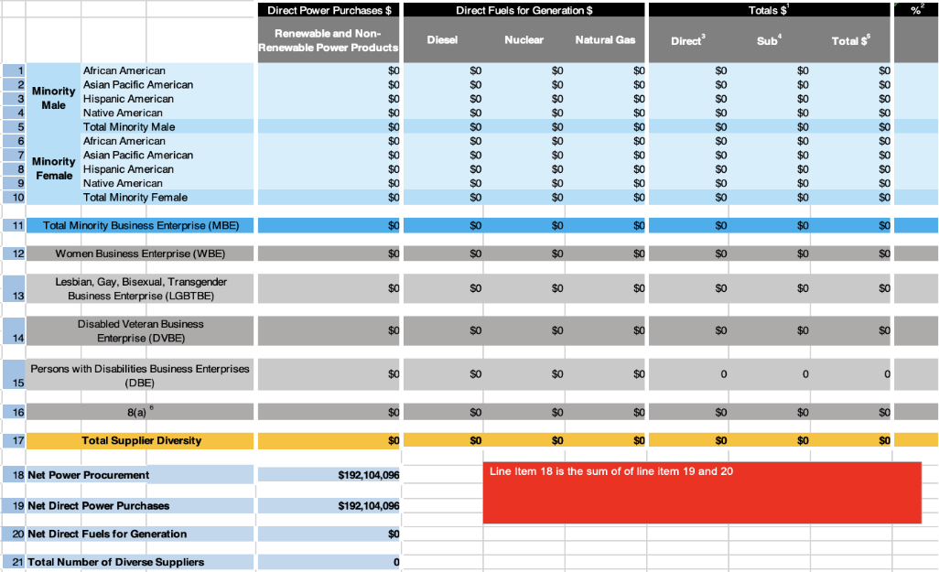
CPUC Notes:
¹ Excludes purchases from the California Independent System Operator (CAISO), utilities, federal entities, state entities, municipalities and cooperatives.
² % - Percentage of Net Procurement.
³ Includes Direct Power Purchases and Direct Fuels for Generation. Direct - Means Direct Procurement: when a CCA directly procures from a supplier.
⁴ Sub - Means Subcontractor Procurement: when a prime contractor, in contract with a CCA, procures from a subcontractor to fulfill its contractual obligation(s).
⁵ "Total" does not include pre-commercial development (COD) subcontracting values.
⁶ 8(a) - Businesses owned and controlled by persons found to be disadvantaged by the U.S. Small Business Administration pursuant to Section 8(a) of the Small Business Act, as amended (15 U.S.C. 637 (a)) or the U.S. Secretary of Commerce, pursuant to Section 5 of Executive Order 11625 (GO 156 Section 1.3.13).

Ava Notes:
Ava also excluded any purchases from any other CCAs.
Non-Renewable Power Products Direct includes 2025 purchases, Carbon-Free Energy (large hydro and ACS), and Resource Adequacy (all resources).
Renewable Power Products Direct includes 2025 long-term renewables contracts payments, as well as Renewable Energy Credit (REC) purchases.
Dollar figures in this table are standard; entered in $MM in supplemental Excel template submitted to CPUC.

2026 Annual Plan

9.1.10 [Title Intentionally Omitted]
Intentionally omitted.

9.1.11 [Title Intentionally Omitted]
Intentionally omitted.

10.1.1 [Title Intentionally Omitted]
Intentionally omitted.

10.1.2 [Title Intentionally Omitted]
Intentionally omitted.

10.1.3 [Title Intentionally Omitted]
Intentionally omitted.

10.1.4 [Title Intentionally Omitted]
Intentionally omitted.

10.1.5 [Title Intentionally Omitted]
Intentionally omitted.

10.1.6 [Title Intentionally Omitted]
Intentionally omitted.

10.2 Description of Supplier Diversity Program Activities Planned for the Next Calendar Year
Prop 209 bars Ava from adopting specific goals or targets in terms of contracting with diverse suppliers. Accordingly, Ava focuses on the engagement of existing prime contractors with the Supplier Diversity program. This takes the form of: 1) identifying and encouraging eligible vendors to complete the certification process––Ava already has a number of vendors in this stage after the 2025 questionnaire was completed––as well as 2) ensuring prime contractors are aware of the Supplier Clearinghouse as they go out to source subcontractors, and 3) continued efforts to reach the business community with educational materials around Ava’s contracting opportunities and GO 156 certification information.

In addition to continued commitments to local purchasing and community grants and scholarships, Ava has also committed to the below activities to include and or continue in 2026.

Internal Activities
- Website and Supplier Resources
  - Ava will continue adding relevant updates and resources to its Supplier Diversity webpage and promote it to businesses and their networks.
- Staff Engagement
  - All Ava staff will attend an annual internal training on GO 156, covering the program overview, requirements, and responsibilities.
- Data Capture and Improved Processes
  - Ava staff have implemented improved internal processes and data-capturing methods to make future reports even more thorough and robust. These initiatives will continue across the organization.

External Activities
- Solicitations
  - Ava will continue including information on the CPUC Supplier Diversity Program in all solicitations and solicitation webinars.
- Diversifying Outreach
  - Ava will continue expanding its outreach efforts beyond its existing network of local community environmental groups, trade organizations, and chambers of commerce. Ava staff will continue outreach and partnership efforts with other local networks to communicate its solicitations and contracting opportunities more directly with these groups.
- CCA Collaboration
  - Ava continues exploring opportunities to collaborate with other CCAs on outreach and education efforts to their supplier ecosystems.
- Power Procurement – Future Long-Term Resource Request for Offers
  - Similar to Ava’s 2024 Long-Term Request for Offers, Ava staff will advertise the CPUC’s Supplier Diversity Program including Ava’s GO 156 reporting requirements, and encourage eligible parties to consider certification in future procurement solicitations.

10.2 Plans to Encourage Prime Contractors to Subcontract Small, Local, and Diverse Businesses
Ava will continue to promote the Supplier Clearinghouse as a valuable database for sourcing subcontractors, highlighting this on Ava’s Supplier Diversity webpage and providing a link to the CPUC Supplier Clearinghouse. In addition to providing a network of vendors to its prime contractors, staff also emphasize its value in helping businesses pursue their own small, local, and diverse procurement goals.

Staff also follow a ‘local first’ approach to contracting opportunities when possible. Ava prioritizes suppliers located in its service territory. For procurements that require a solicitation, potential suppliers may receive points for their small or local business status (although Ava does not make decisions solely based on these classifications). Ava’s emphasis on these priorities naturally encourages prime contractors to pursue small and local subcontractors, as doing so aligns with business needs.

Administrative Procurement Policy.
Net Procurement number as defined by the CPUC GO 156 table templates (i.e. includes purchase order, non-purchase order, and credit card dollars) and CPUC guidance not to include staff salaries and benefits. Net Procurement also excludes all power procurement spend, which is reported on in the Power Procurement Annual Report section.
D.22-04-035, at 19. See also D.22-04-035, Conclusion of Law 2, at 66.
Except for the City of Emeryville, which does not have a Chamber of Commerce.
Community Sponsorships.
Oakland Roots and Soul Sports Club Extended Partnership with Ava Community Energy Video. February 2024.
Solicitations.
Induction Cooking Education and Awareness Grant. August 15, 2023.
Equity Priority Communities. Updated February 2025.
Clean Energy Jobs and Training for Youth Awareness Grant. December 22, 2023.
GO 156 Certification Benefits & FAQs.
All 2025 Resource Adequacy was counted as ‘non-renewable power products’ for the purposes and interpretations of the definitions for this report, despite some capacity coming from renewable resources.

